**Assignment – 3**

**Financial Analytics**

**Title : Analyzing competitive advantage in real companies**

**CONTENT**

* **Introduction**
* **Background**
* **Competitive advantage**
* **Financial performance evaluation**
* **Comparative analysis**
* **Assessment of sustainability**
* **Conclusion**

In this task I am analysing the competitive advantage of two real companies operating in different industries. One company from technology sector i.e. **GOOGLE** and another from the consumer goods sector i.e. **pepsico**.

* **Introduction**

**Company from technology sector : GOOGLE**

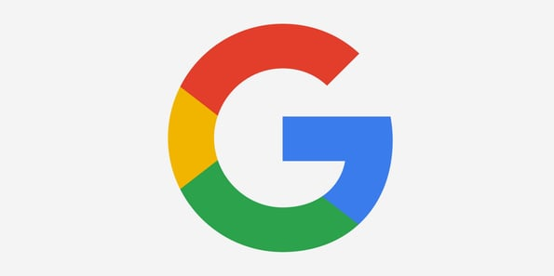

specializing in Internet-related services and products. It was founded by Larry Page and Sergey Brin while they were Ph.D. students at Stanford University. The company was officially incorporated as a privately held corporation on September 4, 1998.

Google's core product is its search engine, which is widely considered one of the most popular and efficient ways to find information on the internet. However, over the years, Google has diversified its offerings significantly.

**Company from consumer goods sector** : **PEPSICO**

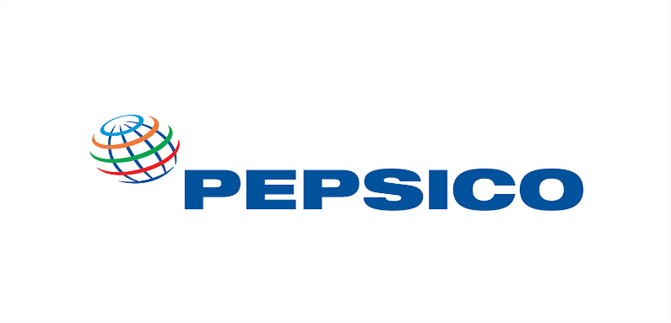

PepsiCo, Inc. is a multinational food and beverage corporation headquartered in Purchase, New York, United States. It was formed in 1965 through the merger of Pepsi-Cola and Frito-Lay. PepsiCo has since grown into one of the largest and most recognizable companies in the world.

PepsiCo operates globally, with its products sold in over 200 countries and territories. The company's success is attributed not only to its strong brand portfolio but also to its innovative marketing strategies, distribution network, and focus on sustainability and corporate social responsibility.

In recent years, PepsiCo has made efforts to diversify its product offerings, introducing healthier snack options, expanding its non-carbonated beverage portfolio, and investing in sustainability initiatives to reduce its environmental impact.

* **Background**

**Company name : GOOGLE**

Google's background is rooted in the collaboration between Larry Page and Sergey Brin, two graduate students at Stanford University in California. In 1996, they began working on a search engine called "Backrub," which utilized a unique algorithm to analyze the relationships between websites to determine their relevance for search queries. This algorithm, known as PageRank, formed the foundation of Google's search technology.

In 1998, Page and Brin incorporated their project as Google Inc., naming it after the mathematical term "googol," which represents the number 1 followed by 100 zeros, reflecting their mission to organize the vast amount of information available on the internet.

Google's breakthrough came with the introduction of its search engine, which quickly gained popularity for its accuracy and efficiency in delivering search results. The company's minimalist interface and emphasis on delivering relevant search results quickly set it apart from other search engines of the time.

As Google's search engine gained traction, the company expanded its offerings, introducing various products and services to complement its search technology. Some of these products include Gmail, Google Maps, YouTube, Android, Google Drive, and Google Chrome, among others.

In 2004, Google went public with its initial public offering (IPO), raising significant capital and solidifying its position as one of the world's leading technology companies. Over the years, Google has continued to innovate and diversify its offerings, expanding into areas such as cloud computing, artificial intelligence, self-driving cars, and hardware devices.

In 2015, Google underwent a major corporate restructuring, forming a new parent company called Alphabet Inc. This restructuring allowed Google to focus on its core businesses, while Alphabet could oversee its various subsidiaries and ambitious projects.

Today, Google remains one of the most influential and innovative companies globally, shaping the way people access and interact with information on the internet and beyond. Its impact extends far beyond search, with its products and services touching nearly every aspect of modern life.

**Company name: PEPSICO**

PepsiCo's history dates back to the late 19th century when pharmacist Caleb Bradham created a soft drink known as "Brad's Drink" in 1893 in New Bern, North Carolina. Brad's Drink, made from a blend of sugar, water, caramel, lemon oil, nutmeg, and other natural additives, gained popularity locally.

In 1898, Bradham renamed his beverage "Pepsi-Cola" and officially registered the trademark. The name "Pepsi" was derived from the word "dyspepsia" (indigestion) and the kola nuts used in the recipe. Bradham believed that the drink aided digestion.

Pepsi-Cola continued to grow in popularity, but due to financial difficulties, Bradham declared bankruptcy in 1923. The Pepsi-Cola trademark and formula were purchased by a group of investors, including Charles G. Guth, who restructured the company and expanded its distribution.

Throughout the 20th century, Pepsi-Cola underwent several ownership changes and mergers. In 1965, Pepsi-Cola merged with Frito-Lay, Inc., a snack food company known for brands like Lay's and Fritos, to form PepsiCo, Inc. This merger significantly diversified PepsiCo's product portfolio, combining soft drinks with snack foods.

Under the leadership of executives like Donald M. Kendall and Roger Enrico, PepsiCo expanded globally and became one of the leading food and beverage companies in the world. The company introduced new products, acquired various brands, and entered new markets, solidifying its position as a major competitor to The Coca-Cola Company.

Over the years, PepsiCo has continued to innovate and adapt to changing consumer preferences. The company has expanded its product offerings to include a wide range of beverages (including non-carbonated drinks like Gatorade and Tropicana) and snack foods (such as Doritos, Cheetos, and Quaker Oats products).

PepsiCo's commitment to sustainability and corporate social responsibility has also been a focus, with initiatives aimed at reducing environmental impact, promoting diversity and inclusion, and supporting communities worldwide.

* **Competitive advantages**

comparing competitive advantages of both the companies.

* **Competitive advantages**

comparing competitive advantages of both the companies.

|  |  |  |
| --- | --- | --- |
| **Company name** | **GOOGLE** | **PEPSICO** |
| **Brand reputation** | Google has a very strong brand reputation and perception in the tech industry. It is widely seen as a leader in innovation and technology, and it is one of the most popular and trusted brands in the world.  Google is known for its high-quality products and services, such as its search engine, email service, and cloud computing platform. It is also known for its strong company culture and its commitment to diversity and inclusion.  However, Google has also faced some criticism in recent years. For example, the company has been criticized for its data collection practices, its tax avoidance strategies, and its role in the spread of misinformation. | According to Comparably, PepsiCo has a 4.1/5 product quality score and an 81% customer loyalty score. PepsiCo's Net Promoter Score (NPS) is 27, with 54% promoters, 19% passives, and 27% detractors.  In 2022, PepsiCo was named the top food, beverage, and tobacco industry company on the 100 Best Corporate Citizens list, and second overall, for its environmental, social, and governance (ESG) transparency and performance. PepsiCo also received an AA rating in the MSCI ratings assessment in 2022.  In the United States, 43% of soft drink drinkers say they are likely to use Pepsi again, which means 84% of their drinkers are loyal to the brand. |
| **Product differentiation** | The generic strategy of differentiation means that Google must maintain its competitive advantage based on uniqueness. It is of critical importance for the firm to continue innovating. A corresponding strategic objective is to develop new products or continue improving existing products. | PepsiCo differentiates its products by offering new products, improving existing products, and emphasizing taste. For example, PepsiCo offers low-calorie, reduced-salt, and low-saturated-fat variants of its products. PepsiCo also emphasizes its taste, which helps it gain market share. |
| **Technological innovation** | Google has been developing artificial intelligence (AI) for at least a decade, and is considered a leader in the field. Google's AI has reshaped the technology landscape, and includes projects such as Google Assistant, computer vision, and ethical AI practices. | PepsiCo has been using artificial intelligence (AI), big data, analytics, and drones to digitally transform its operations. The company has also partnered with startups to achieve new goals, |
| **Market leadership** | Google is the market leader in search engines, with over 90% of the global share. As of November 2023, Google handles 91.54% of all search queries. Bing and Yahoo! are the next largest search engines, but combined they make up less than 5% of the total market share. Baidu, the search engine used in China, and Yandex, the search engine used in Russia, both have around 1% of the market share.  Top of Form  Bottom of Form | PepsiCo is one of the market leaders in the non-alcoholic beverage industry, along with Coca-Cola. In 2021, PepsiCo was the second most valued soft drink brand in the world, with $18.4 billion, while Coca-Cola was the first, with $33.2 billion. However, both companies have seen a decline in market share due to increased competition. |
| **Distribution network** | The Search Network: Google search results pages, other Google sites like Maps and Shopping, and search sites that partner with Google to show ads. The Display Network: Google sites like YouTube, Blogger, and Gmail, plus thousands of partnering websites across the Internet. | Pepsi's products are primarily brought to market through direct store delivery (DSD), customer warehouse, and distributor networks and are also sold directly to consumers through e-commerce platforms and retailers. |

* **Analysing financial performance**
* **Analysing financial performance of**

**Technology company : GOOGLE**

Analyzing the financial performance of Google, now a subsidiary of Alphabet Inc., involves examining key financial metrics and trends to assess the company's profitability, revenue growth, financial stability, and efficiency. Here's an overview of how to analyze Google's financial performance:

1. **Revenue Growth**: Look at Google's revenue growth over multiple periods, such as quarterly or annually. Revenue growth indicates the company's ability to generate sales and expand its business. Pay attention to revenue growth rates for Google's core products and services, including advertising, cloud computing, and other segments.
2. **Profit margin**: Operating Margin as of March 2024 (TTM): 25.49%According to Alphabet (Google)'s latest financial reports and stock price the company's current Operating Margin is 25.49%. At the end of 2022 the company had an Operating Margin of 25.22%

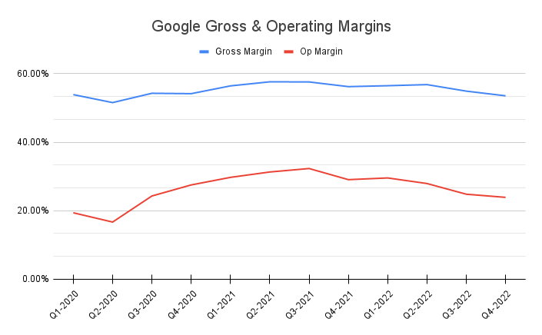

1. **Return on investment :** Alphabet (Google) has an annualized return on invested capital (ROIC) of 31.40% for the quarter that ended in December 2023. This means that Google earns more than it costs the company to raise capital for investments, and is earning excess returns.

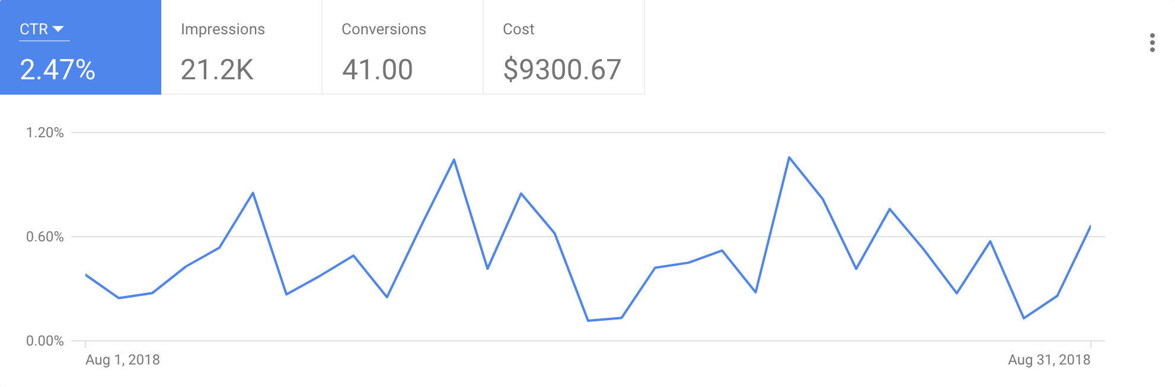

4.**Market share :** As of June 2022, Google has a global search engine market share of 91.88%, with market share fluctuating between 86% and 96% depending on location. In 2024, Google has a market share of over 92% in India, and is the dominant internet search provider in many major online markets. In North America, Google has an 89.08% market share, and in Europe, it has a 91.91% market share.

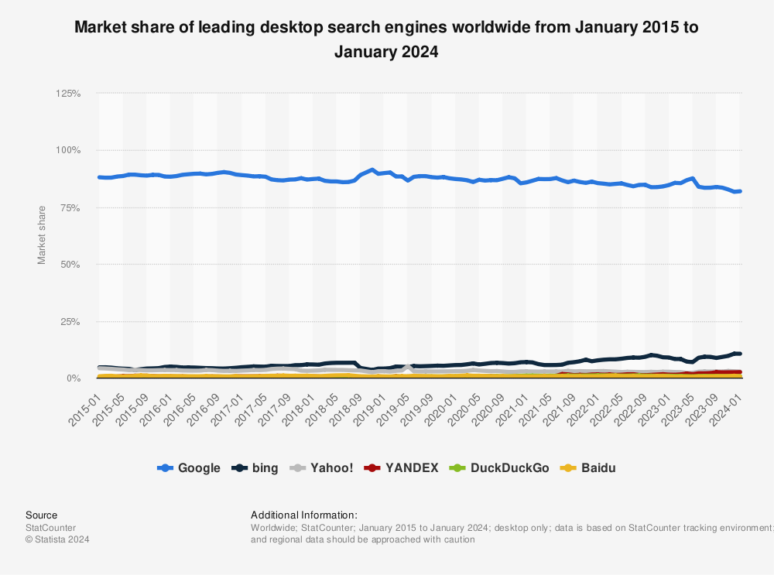

By analyzing these financial metrics and trends, investors and analysts can gain insights into Google's financial performance, strengths, and areas for improvement. It's important to consider both quantitative and qualitative factors when assessing the company's long-term prospects and investment potential.

* **Analysing financial performance of**

**Consumer goods service company : PEPSICO**

**REVENUE GROWTH :** PepsiCo's revenue in 2023 was $91.47 billion, which is a 5.88% increase from 2022. This includes growth of 5.9% globally, and mid-single-digit growth in developing and emerging markets like China and India. However, the AMESA division, which includes India, saw a 4.64% decline in revenue due to unfavorable foreign exchange and a decline in net organic volume.

**Profit margin:**

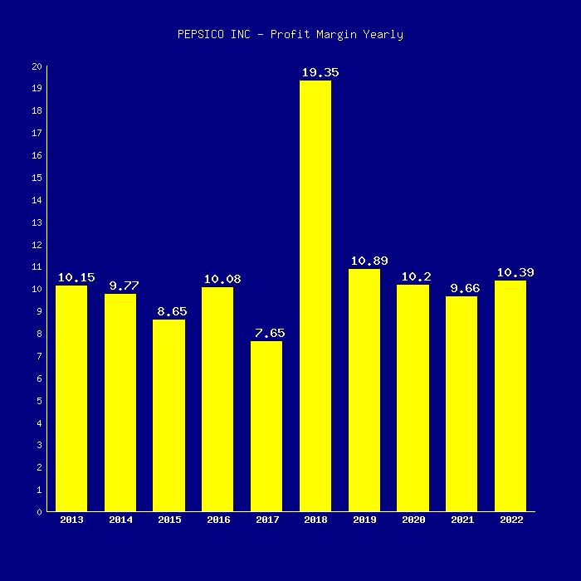

**RETURN ON INVESTMENT**

PepsiCo's return on investment (ROIC) is 12.83%, which means the company generates higher returns on investment than it costs to raise the capital. The company's average ROI is 16.35%, and in the third quarter of 2023, it achieved an ROI of 13.36%. This is due to net income growth, and the ROI has improved from 12.69% in the second quarter of 2023.

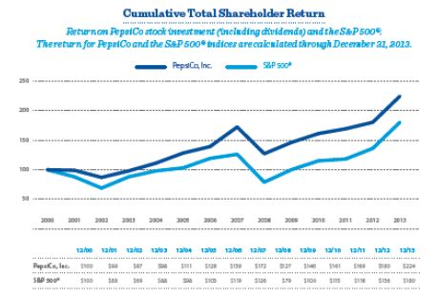

**Market share:**

In 2022, PepsiCo had a 24.3% market share in the U.S. for carbonated soft drinks, while Coca-Cola had 46.3%. PepsiCo's market share has been slowly decreasing since 2021, when it stood at 8.9%

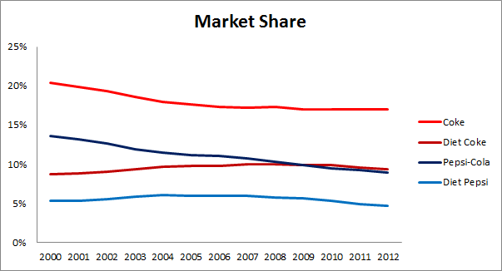

* **Assessment of sustainability**

Technology company: GOOGLE

Google, as a major technology company, has made significant strides in sustainability efforts in recent years. Here are some aspects of Google's sustainability initiatives:

1. **Renewable Energy**: Google has committed to using renewable energy to power its operations. The company has invested heavily in renewable energy projects such as wind and solar farms. In 2017, Google announced that it had achieved 100% renewable energy for all of its global operations, including data centers and offices.
2. **Carbon Neutrality**: Google has set ambitious goals to achieve carbon neutrality and reduce its carbon footprint. The company has implemented energy-efficient practices in its data centers and offices, such as using advanced cooling systems and optimizing server efficiency. Google also offsets its carbon emissions through investments in carbon offset projects.
3. **Circular Economy**: Google aims to promote a circular economy by minimizing waste and maximizing resource efficiency. The company has implemented recycling programs and waste reduction initiatives in its operations. Google also designs its products with sustainability in mind, using recycled materials and designing for longevity and recyclability.
4. **Water Conservation**: Google is committed to conserving water resources and minimizing water usage in its operations. The company has implemented water-saving measures in its data centers and offices, such as using recycled water for cooling systems and implementing water-efficient landscaping practices.
5. **Supply Chain Sustainability**: Google works with its suppliers to promote sustainability throughout its supply chain. The company encourages suppliers to adhere to environmental and social responsibility standards, such as reducing greenhouse gas emissions, conserving water, and respecting human rights.
6. **Transparency and Reporting**: Google is transparent about its sustainability efforts and regularly publishes reports on its environmental impact and progress towards sustainability goals. The company provides detailed information on its energy usage, carbon emissions, and other sustainability metrics.
7. **Community Engagement**: Google engages with local communities to support sustainability initiatives and address environmental challenges. The company invests in community projects focused on renewable energy, environmental conservation, and education. Google also supports organizations working on environmental issues through grants and partnerships.

Overall, Google's sustainability efforts demonstrate a commitment to environmental responsibility and corporate citizenship. While the company continues to face challenges in mitigating its environmental impact, Google's initiatives and investments in sustainability reflect a proactive approach to addressing climate change and promoting a more sustainable future.

* **Assessment of sustainability**

Consumer goods sector: PEPSICO

Assessing the sustainability efforts of PepsiCo involves evaluating various aspects of the company's environmental, social, and governance (ESG) practices. Here are some key areas to consider when assessing PepsiCo's sustainability:

1. **Environmental Impact Reduction**: PepsiCo has implemented measures to reduce its environmental impact across its operations. This includes efforts to minimize water usage, optimize packaging materials to reduce waste, and improve energy efficiency in manufacturing and distribution processes. Assessing the effectiveness of these initiatives involves examining metrics such as water usage efficiency, waste diversion rates, and greenhouse gas emissions reduction targets.
2. **Sustainable Sourcing**: PepsiCo has committed to sustainable sourcing practices for its agricultural ingredients, such as potatoes, corn, and oats used in its snacks and beverages. Evaluating PepsiCo's sustainable sourcing efforts involves assessing the company's support for sustainable agriculture practices, responsible land use, and efforts to promote biodiversity and protect ecosystems in its supply chain.
3. **Packaging Innovation**: PepsiCo has focused on innovating packaging solutions to reduce environmental impact, such as lightweighting packaging materials, increasing recyclability, and incorporating recycled content. Assessing PepsiCo's packaging sustainability involves analyzing the recyclability and post-consumer recycled content of its packaging, as well as efforts to reduce single-use plastics and promote circular economy principles.
4. **Community Engagement and Social Impact**: PepsiCo engages with local communities through various social impact initiatives, including investments in education, nutrition, and community development programs. Evaluating PepsiCo's social impact involves assessing the effectiveness of its community engagement efforts, the alignment of its initiatives with local needs, and the outcomes achieved in terms of social welfare and empowerment.
5. **Diversity and Inclusion**: PepsiCo promotes diversity and inclusion in its workforce and business practices. Assessing PepsiCo's diversity and inclusion efforts involves examining workforce demographics, representation in leadership roles, and initiatives to foster an inclusive workplace culture. Additionally, evaluating PepsiCo's efforts to support diversity in its supply chain and marketing practices can provide insights into its commitment to equity and inclusion.
6. **Corporate Governance and Ethics**: PepsiCo is expected to uphold high standards of corporate governance, transparency, and ethical business conduct. Assessing PepsiCo's governance practices involves reviewing its board composition, executive compensation practices, disclosure of ESG metrics, and policies related to risk management, compliance, and anti-corruption.
7. **Stakeholder Engagement and Reporting**: PepsiCo's engagement with stakeholders, including investors, customers, employees, and civil society organizations, is essential for assessing its sustainability performance. Evaluating PepsiCo's stakeholder engagement involves analyzing its communication and reporting practices, responsiveness to stakeholder concerns, and mechanisms for accountability and transparency.

Overall, assessing PepsiCo's sustainability involves evaluating its performance across environmental, social, and governance dimensions, as well as its commitment to continuous improvement and accountability in addressing sustainability challenges. By considering these factors, stakeholders can gain insights into PepsiCo's sustainability practices and their impact on long-term value creation.

**Conclusion**

**1 . GOOGLE**

In conclusion, Google's sustainability efforts demonstrate a proactive commitment to environmental responsibility and corporate citizenship. The company has made significant strides in reducing its environmental impact, promoting renewable energy usage, and fostering sustainable practices across its operations. Google's initiatives encompass various aspects of sustainability, including energy efficiency, waste reduction, water conservation, and supply chain sustainability. Through transparency, reporting, and community engagement, Google actively communicates its sustainability goals and progress, fostering accountability and stakeholder trust. While challenges remain, Google's dedication to sustainability reflects its recognition of the importance of addressing environmental challenges and contributing to a more sustainable future. As Google continues to innovate and evolve, its sustainability efforts will play a crucial role in shaping its long-term success and impact on society and the environment. In conclusion, PepsiCo's sustainability efforts underscore its commitment to environmental stewardship, social responsibility, and ethical business practices. The company has implemented a range of initiatives aimed at reducing its environmental footprint, promoting sustainable sourcing, and fostering community engagement. PepsiCo's focus on innovation in packaging, energy efficiency, and water conservation demonstrates its dedication to addressing pressing environmental challenges.

Moreover, PepsiCo's social impact initiatives, including investments in community development, nutrition programs, and diversity and inclusion efforts, reflect its commitment to improving societal well-being and fostering inclusive growth. By engaging with stakeholders, promoting transparency, and setting ambitious sustainability goals, PepsiCo is actively working to create long-term value for both shareholders and society.

While there are ongoing challenges and areas for improvement, PepsiCo's sustainability efforts represent a positive step towards building a more sustainable and resilient business model. As the company continues to evolve and innovate, its commitment to sustainability will be integral to its long-term success and ability to create positive impact for future generations.

**Name : B. BAVYA NANDINI LAKSHMI**

**College : DR. Lankapalli Bullayya College**

**2.PEPSICO**